Task 3.1.0

Complete it by 2nd June.

Feel free to discuss any doubts & bugs in a community group. We will conduct the Live doubt session of FreeCodeCamp on Friday 2nd June.

The 2nd quiz will be available on Friday 26 May.

Mentoring Videos: You must apply them.

Video 1:

[Khudi (Self-Respect & Self-Esteem) | Motivational Video by Shaykh Atif Ahmed | Al Midrar Institute](https://www.youtube.com/watch?v=44k_Lu8-WXc)

Video 2:

Very important speech.

[Shykh Atif Ahmed On ERC Inauguration Ceremony | Life Changing Lecture Emotional Speech in Gujranwala](https://www.youtube.com/watch?v=kJBt3CVK4dI)

Free Code Camp

# **Responsive Web Design Certification**

Web link:

<https://www.freecodecamp.org/learn/2022/responsive-web-design/>

**1) Complete it by (27 May) Saturday night :**

***317 exercises on HTML & CSS and survey form project.***

**CodeBite Line Managers will get an update via a 10-minute sprint meeting on 317 exercises on Friday night.**

**Be prepared for this.**

**Do not take it lightly. It will take a lot of your time and effort. Give them proper time.**

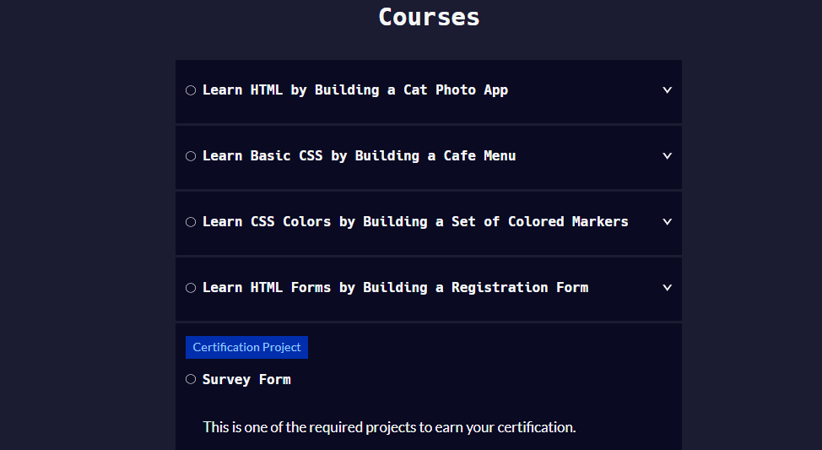

**2) Complete it by (30 My) Tuesday night:**

**201 + 188 = 389 exercises on HTML & CSS and Tribute page project & Technical documentation page.**

**CodeBite Line Managers will get an update via a 10-minute sprint meeting on 317 exercises by (29 May) Monday night. Be prepared for this.**

**Do not take it lightly. It will take a lot of your time and effort. Give them proper time.**

**2.1) 201 exercises**

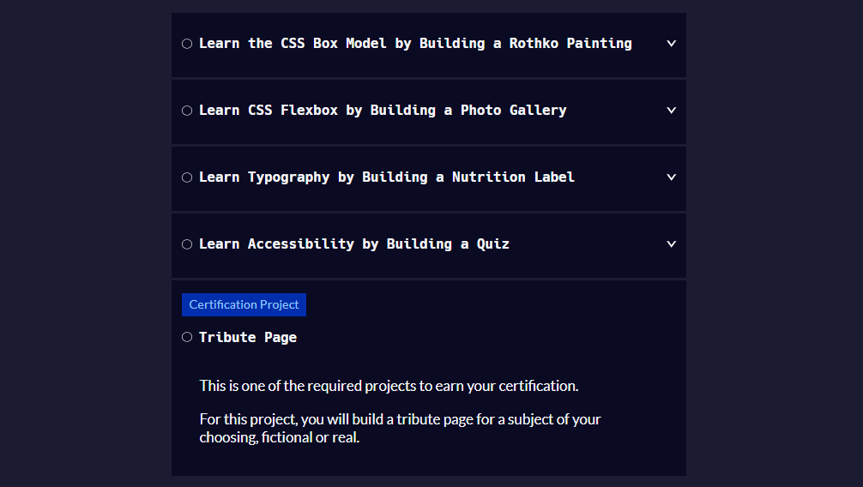

**2.2) 188 exercises**

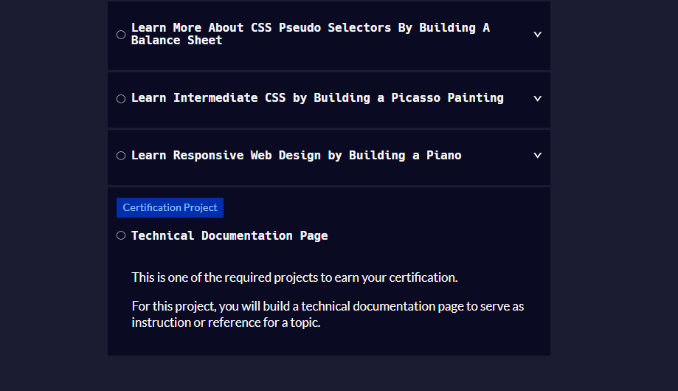

**3)Complete it by (2nd June) Friday night:**

**198 + 133 = 331 exercises on HTML & CSS and Product Landing Page project & Personal Portfolio Webpage project.**

**CodeBite Line Managers will get an update via a 10-minute sprint meeting on 317 exercises by (1st June) Thursday night.**

**Be prepared for this.**

**Do not take it lightly. It will take a lot of your time and effort. Give them proper time.**

**3.1) 198 exercises**

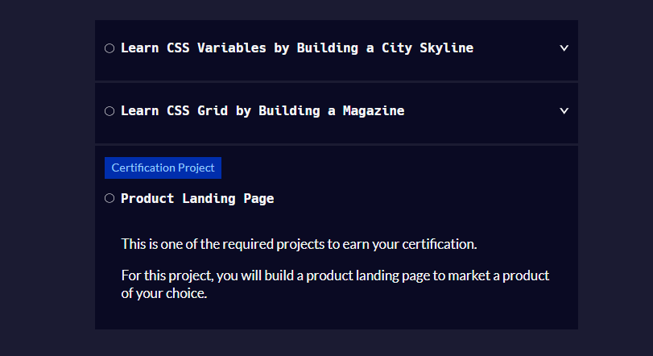

**3.1) 133 exercises**

